De winnende nummers van de spaghetti Take Away:
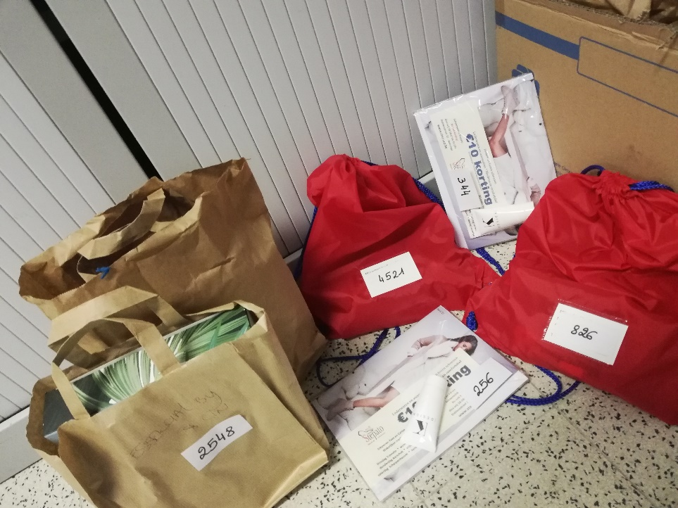
- 5
- 10
- 31
- 33
- 141
- 256
- 344
- 375
- 493
- 500
- 555
- 628
- 826
- 1086
- 1111
- 1256
- 1291
- 1632
- 1767
- 2138
- 2543
- 2548
- 3001
- 3111
- 3180
- 3441
- 3722
- 4235
- 4394
- 4396
- 4521
- 5440

